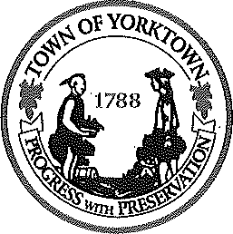

Yorktown Town Hall

363 Underhill Avenue, P.O. Box 703 Yorktown Heights, NY 10598

(914) 962-5722
www.yorktownny.org

FOR IMMEDIATE RELEASE

Yorktown approves retail, self-storage, energy sites

YORKTOWN, N.Y. (December 22, 2020) – The Planning Board approved three site plans last night for a specialty grocer, the conversion of an empty big box store and a battery energy storage facility.

The owner of the Lowe’s Home Center at 3240 Crompond Road received an approval for a specialty grocer that will occupy a 12,500-square-foot space at the shopping center. The name of the specialty grocer has not been revealed by the property owner, but it is expected to be a Trader Joe’s.

Columbia Pacific Advisors received approval for a CubeSmart self-storage facility at the former Toys R Us building with two one-story additions of 11,217 square feet and 13,254 square feet. The 3.6-acre parcel at 621 Bank Road will also receive associated landscaping, parking and lighting.

Yorktown Energy Storage received approval to construct a 15,000 kWh/5,000 kW Tier 2 battery-energy storage system at 3901 Gomer Court. The battery storage is possible under new legislation adopted by the Town Board earlier this year. Battery storage facilities take surplus electricity from the grid when demand is low and return the electricity to the grid at times of peak demand.

“All three of these projects will help advance Yorktown’s economic revival and transformation,” said Supervisor Matt Slater. “The specialty grocer is an acknowledgement that our community is an attractive market for national retailers. The conversion of the old Toys R Us represent a great leap forward in our efforts this year to find new uses for outdated big-box stores. And the battery storage site demonstrates Yorktown’s commitment to strengthening our power grid’s reliability.”

Contact: Yorktown Supervisor Matt Slater, 914-962-5722 x201 or mslater@yorktownny.org

